ENCRYPTION

Kevin Cherry

December 2006

CSC 4330
TABLE OF CONTENTS

Introduction ------------------------------------------------------------------------ 1 - 2
Origin -------------------------------------------------------------------------------- 2 - 3
Methods ----------------------------------------------------------------------------- 3 - 6
Hash functions ---------------------------------------------------------------------- 6 - 8
Encryption vs. Hashing ----------------------------------------------------------- 8 - 9
Conclusion --------------------------------------------------------------------------- 9
Figures ------------------------------------------------------------------------------- 10 - 14
Works Cited ------------------------------------------------------------------------- 15
Tips for creating/picking your own method --------------------------------- 16 – 17 Encryption methods comparison ---------------------------------------------- 18
Encryption is in no way a new method of storing data securely yet there is so much not understood about it. First off, what is encryption? The definition for encryption can be found in numerous places. One such place is from The Columbia Encyclopedia, where they state, “[encryption is] the process of scrambling stored or transmitted information so that it is unintelligible until it is unscrambled by the intended recipient.” (http://www.bartleby.com/65/da/dataencr.html). Another definition can be found from Hermetic Systems: “Encryption is any procedure to convert plaintext into ciphertext. Decryption is any procedure to convert ciphertext into plaintext.” (http://www.hermetic.ch/crypto/intro.htm). Allow me to define for you what plaintext and ciphertext is at this time. “Unencrypted data is called plain text ; encrypted data is referred to as cipher text” (http://www.webopedia.com/TERM/e/encryption.html). The subject of encryption is part of cryptography. “Cryptography is about communication in the presence of an adversary. It encompasses a large variety of topics, such as encryption, authentication, and key distribution” (source from ACM computing reviews). A key is the information necessary to decrypt a message. Message integrity is how well the information is kept intact and not altered from the time sent to the time it is received by the intended receiver. Data origin authentication is the verification that the message has come from the correct source that is said to have sent it (Dent and Mitchell, p.45). With this basic terminology out of the way, the full description of what encryption really is, how it is used, when and where it first started, and a good bit more can now be explained.
So what exactly is encryption? I have given you two informal definitions but to give you a better understanding of just what these definitions mean, I will use a scenario. Let’s say that you have just finished writing down a new idea you have come up with. You have full plans to get a patent for this new idea and try to market it. The problem is that you are a little worried about this information falling into the wrong hands. What is a way that you can safely store this information on your computer without fear of the wrong person reading it? This is where encryption comes in. You have some information that is important to you, or perhaps your company and you don’t want it falling into the hands of someone who can misuse it. Encryption is a method that seeks to remedy this problem by converting the plaintext, i.e. what you have written down, into something that would resemble incoherent or perhaps just different text than what was originally said. Let’s say that one of the sentences you have written down is, “This idea could make me millions!” Anyone seeing this message would be very interested in what else the document has to say. On the other hand, if the text where “Guvf vqrn pbhyq znxr zr zvyyvbaf!” the reader would have no interest in reading any further as this would make no sense to him. This is an example where plaintext is converted into something illegible by any human reader, yet if the right program is used, this text can be decrypted back into the plaintext so it can then be read by the intended recipient. Think about when you logon to a website. You don’t want your password to be stored as is on the site for anyone who knows what they are doing to get. Most, almost all with important data to hold, websites encrypt your password so hackers have a much more difficult time getting personal information from your login account. Is this starting to sound interesting? Good, because there is much more to learn.
So where did the idea of manipulating text for security come about, well you might be surprised to know that the first example of written cryptography has actually been documented to take place in 1900 BC (reference figure 1) (http://world.std.com/~cme/html/timeline.html). Cryptography, as you can see, is definitely not limited to using computers nor is computers the reason why cryptography came about. The desire to hide written text from prying eyes is just a matter of privacy in that we don’t want another person knowing something they shouldn’t. In fact around 1250 AD, a man by the name of Roger Bacon had this to say about cryptography, “A man is crazy who writes a secret in any other way than one which will conceal it from the vulgar.” (figure 1)
Now that you have a good understanding of the idea and desire behind encryption, let’s look at some methods of encryption. Most encryption methods are quite heavy in math and the average programmer will need a bit of a refresh and possibility a course or two to be able to understand them. The methods I will present to you, however, are not very heavily rooted in mathematics so they should be a lot easier to understand. One such method, called Vigenere Cipher, was used during the Civil War, but dates back to the 1500’s. This method can encrypt the same text many different ways depending on the key given, but can only encrypt letters and is case insensitive. The method itself is simple. Simply create a matrix with rows and columns going from A-Z skipping a letter for each successive row/column (reference figure 2) and then follow the algorithm:
Write key letters under message letters. Look for the message letter on top line of table, then move down until you reach the row whose left-most letter is that of key letter. Example; when L is extended down two rows to C of key, N is the cipher letter.
[Example from the site. Key = comeretribution]
Message: Longstreet to move at once into Petersburg defence.
Key: COMERETRIB UT IONC OM ERET RIBU TIONCOMERE TRIBUTI
Cipher: NCYKJXKVMU NH UCIG OF SEGX ZVUI IMHRTGNYIK WVNFHVM
(http://pages.cthome.net/fwc/CODE.HTM)
A very easy method of encryption evolves from the idea of rotating letters. This method, called ROT13, gets its name from the simple way that it works. Edoceo, inc explained the process like this:
ROT13 simply takes the alphabetical characters of the input and will ROTate them 13 places. The 13 places depends on the position of the letter, lower letters get pushed up, and the higher letters get pulled down […] Sometimes the ROT13 is called the Caesar-cypher as it is said he used ROT13 for communication during the Pelloponesian Wars (http://www.edoceo.com/utilis/rot13.php)
So for example, if the letter is ‘w’, you would count 13 places to the right ’x’,’y’,’z’, ‘a’, ‘b’, and so on ending on the letter ‘j’. The text “Guvf vqrn pbhyq znxr zr zvyyvbaf!” shown earlier was encrypted using this method. There are also variations of this method where a value, N, is given which represents the number of letters to rotate each letter in the text. So rot(3) for example will rotate each letter 3 letters to the right. There is a problem with these variations, however, as stated by DeGraeve.com, “A major advantage of rot13 over rot(N) for other N is that it is self-inverse, so the same code can be used for encoding and decoding.” (http://www.degraeve.com/rot13.php) Unfortunately this is also a security issue as it makes this method all too easy for your average cryptanalysis, “The analysis and deciphering of cryptographic writings or systems” (http://www.answers.com/topic/cryptanalysis), to decipher.
These two methods are examples of private key encryption that is the method of the encryption is not public knowledge and is only known to the one encrypting the message and the one who is intended to receive the message. There is another type of encryption where the encryption method is public and anyone can gain knowledge of it, but the decryption method with which to actually decrypt the ciphertext, is private and as stated above, is only known to the sender and intended receiver of the message. A book on public-key cryptography by Brauer, Rozenberg, and Salomaa stated this:
There are systems in which you can safely publicize your encryption method. This means that also the cryptanalyst will know it. However, he/she is still unable to decrypt your cryptotext. This is what public-key cryptography is all about: the
encryption method can be made public. (p. 55)
This kind of encryption is known as public/private key Cryptography.
Now I will discuss the most talked about, most controversial topic on encryption: The Da Vinci Code. The Da Vinci Code has become a topic of modern discussion on encryption, and this paper wouldn’t be quite complete without the mention of it. You see it is a lot more than just a popular movie staring Tom Hanks; it is also an encryption system program, a popular book, and a story of what could be “about the history of encryption” (http://www.wired.com/news/culture/0,1284,58378,00.html). The book talks about the myth, called so due to the disbelief of many theorists saying that it is a work of fiction, explaining it in detail. Apparently Leonardo Da Vinci hid messages in his artworks. For example, The Last Supper is said to have depicted Mary Magdalene to the right of Jesus Christ instead of what has been believed by many to be disciple John. Some theorists have gone as far as to suggest that Jesus and Mary make the letter ‘M’ with their bodies which could stand for Mary, Matrimony, or perhaps something else. Another famous painting of Da Vinci is The Mona Lisa where it is said that the woman portrayed is actually Da Vinci himself in feminine form. The comparison of one of Da Vinci’s self-portraits to The Mona Lisa reveals not only a strong resemblance but also the facial features appear to line up in the two paintings. This may seem a little bit far fetched but did you know that Da Vinci actually wrote down all his notes in mirror writing, that is, writing that can only be read when held up to a mirror? (http://www.unmuseum.org/leocode.htm) Da Vinci was no stranger to encryption practices so the idea of him hiding meanings into his paintings is not nearly as implausible as you might think. The most intriguing encryption method that some people accredit Da Vinci as creating is the cryptex.
A cryptex is a tube constructed with a series of rings with letters of the alphabet engraved on them. When the rings are turned so that certain letters line up to the cryptex's password, one of the end caps can be removed and the contents (usually a piece of papyrus wrapped around a glass bottle containing vinegar) can be removed. Should someone try and get at the message by smashing the device, the glass bottle will break and the vinegar will dissolve the papyrus before the message on it can be read. […] the cryptex is a fictional device created by Dan Brown and credited to Leonardo in his popular book, The Da Vinci Code. There is no evidence that Leonardo actually conceived or built such a device. (http://www.unmuseum.org/leocode.htm)
Even though the cryptex is thought to be fictional it is still a perfect example of how creative an encryption method can be. This shows that encryption does not always have to be in the form of converting text but can be formed from any attempt to hide a meaning. For more information the book, The Da Vinci Code, is an excellent resource.
Encryption is a two-way method meaning that the plaintext can be converted into ciphertext and then converted back into plaintext. Hashing, on the other hand, is a one-way method meaning that once the plaintext is converted, it can not be converted back. Because of this using a hash function on any given text will always produce the same cipher text. This text is then used to determine whether two plaintexts are equal. For example when using your password on a website, if the same hash function is used on the password typed in at logon as it was used on the password when you last changed/created it, then it should produce the same result. So when you type in your password, the hash function is used and the result is compared with what is stored on the website. If they match you must have entered in the right password. Another example of this was found from the Webopedia, explaining it this way:
Hashes play a role in security systems where they're used to ensure that transmitted messages have not been tampered with. The sender generates a hash of the message, encrypts it, and sends it with the message itself. The recipient then decrypts both the message and the hash, produces another hash from the received message, and compares the two hashes. If they're the same, there is a very high probability that the message was transmitted intact.
(http://www.webopedia.com/TERM/H/hashing.html)
This example is also illustrated in the hash function MD5, which stands for Message Digest 5 (reference figure 3). The figure shows two documents and how even if they differ on a single character, the MD5 sum (which is the result of running the MD5 hash) will be different. Ondrej Mikle, from the Department of Software Engineering at Charles University in Czech Republic, had this to say in regards to figure 2:
From the user's point of view the situation is: user receives two files –
self-extract.exe and data.pak. He can check MD5 sum of both files. User runs self-extract.exe and the program using data.pak extracts the document itself - contract.pdf. Other user receives the same self-extract.exe, but different data.pak. Both data.pak files are created so that their MD5 sum is identical. Therefore, both users think that the contracts extracted are the same in both cases. (http://eprint.iacr.org/2004/356.pdf)
The comparison of the two sums is called a hashcheck. There are many other different types of hash functions that are widely used today. Hashing functions can be used in other ways to store data and make is quickly accessible. These properties of hashing are out of the scope of this paper, though.
The main difference between hashing and encrypting is that with hashing, the plaintext can never be derived from the ciphertext. This can be a problem if, say, you are using a hash function for the password of your website and the user has forgotten his password and would like it emailed to him. This is impossible if the only data stored is a hash of his/her password. As far as data security, however, hashing is clearly the victor over encryption for the same reason. Hashing encrypts text into a hexadecimal number of fixed length causing it to be better on memory storage as well. This can be a problem though as this means that two strings can potentially have the same hash sum even though they are different, a problem that many hash functions seek to resolve. Most of the more popular hash functions used today have very good collision resolution where duplicates are mostly avoided. Encryption can, and is in fact encouraged to have, multiple ciphertext possibilities for the same plaintext, while hashing can only have one possibility per plaintext. If hashing had more than one possibility, then there would be no guarantee that two documents will result in the same hash sum even if there contents are identical.
There are many methods of encryption not talked about in this paper. To cover them all would take a book easily over 1000 pages! My main purpose, instead, was to introduce you to some of the different types of encryption and let the encryption methods mentioned serve as an example of that type of encryption. You have seen that encryption doesn’t just involve written text as you may or may not have originally thought. You have also seen how methods other than encryption can encrypt text as the method of hashing was introduced and compared with encryption in general. Attached to this paper you will find tips to help you in choosing or creating your own encryption method if you desire to, as well as how the encryption methods talked about compare to each other in the points mentioned on the tips. I have also included a short program so you can use the encryption methods talked about as well as an encryption method I have created myself. Encryption is not new as it has been around for ages, but the study of encryption is still as exciting today as it was back then.
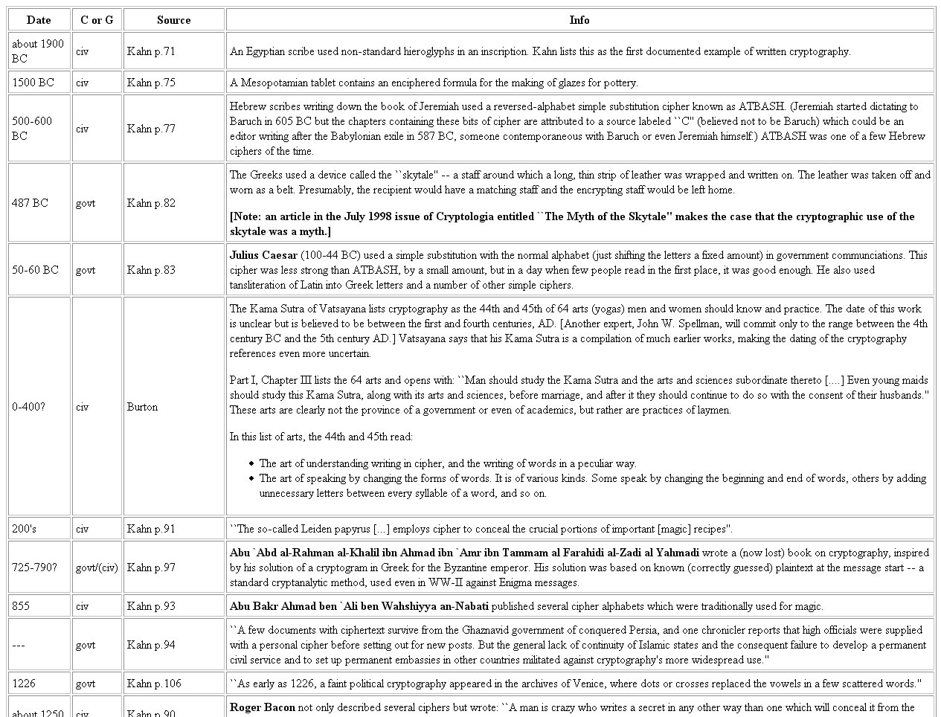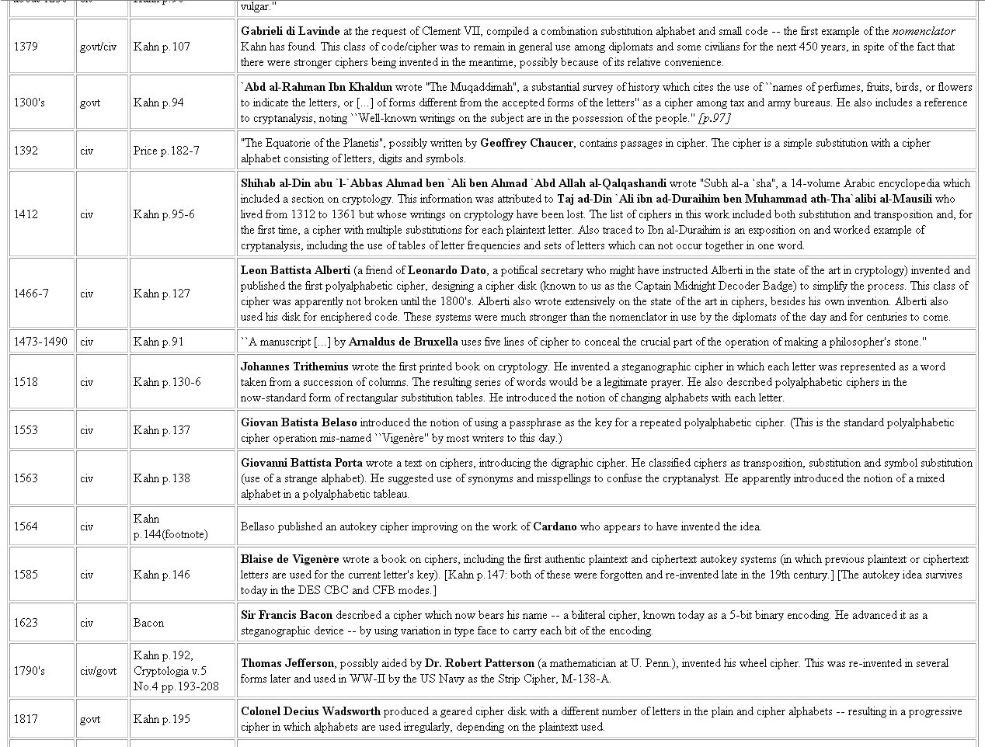
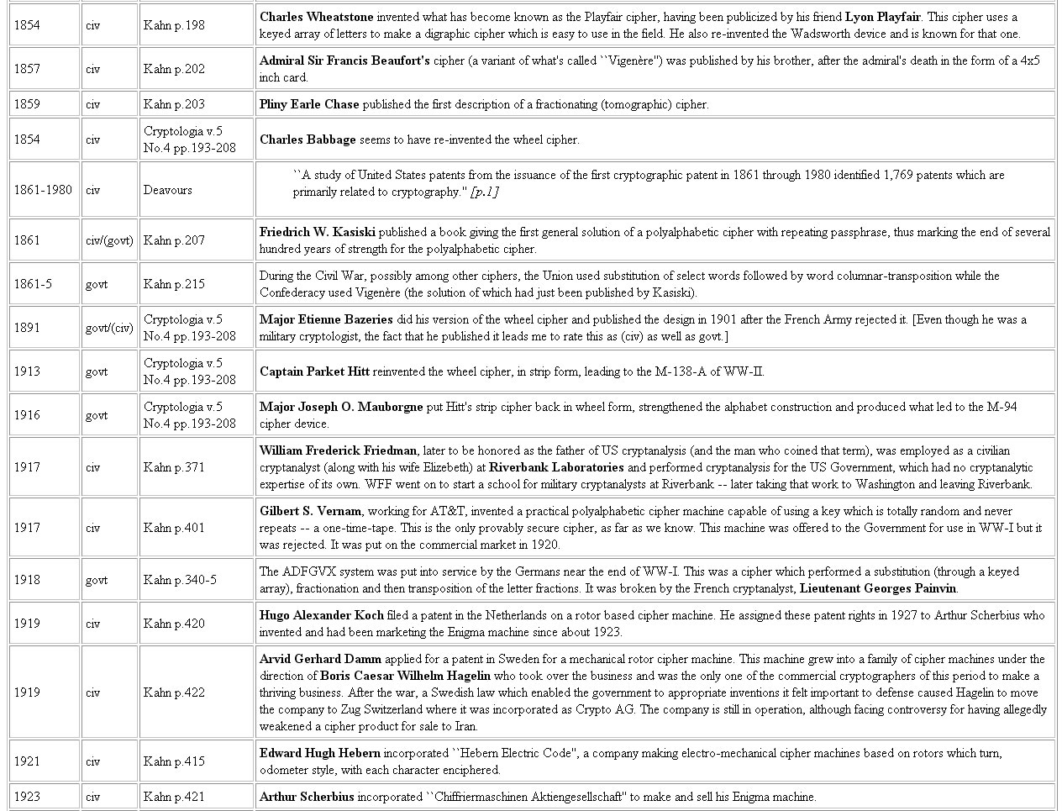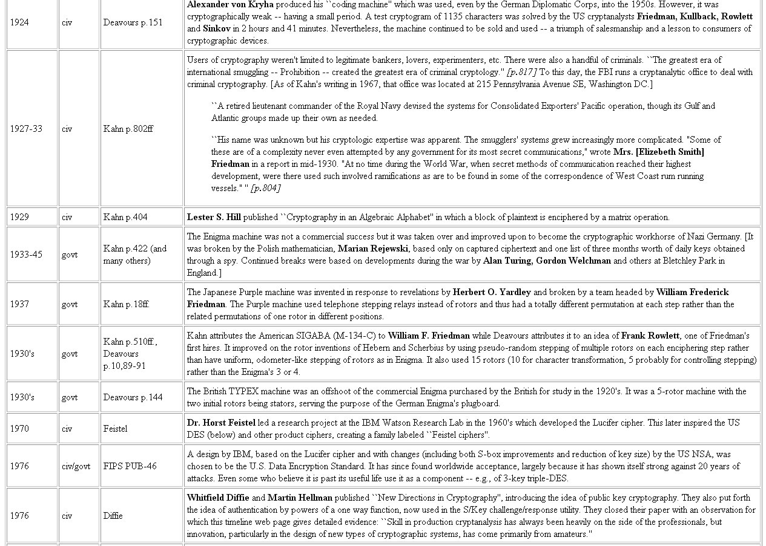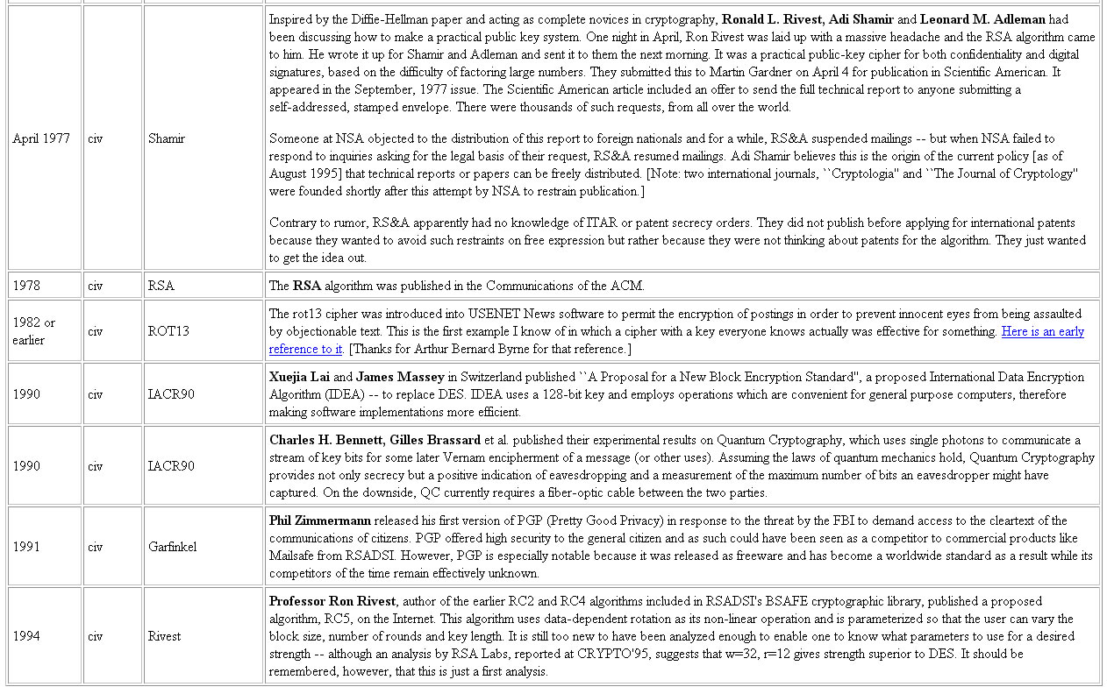

<Figure 1>
(Table obtained from http://world.std.com/~cme/html/timeline.html.)

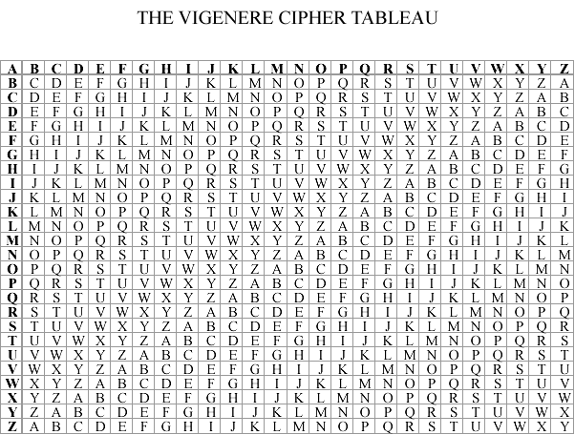

<Figure 2>
(Information obtained from http://pages.cthome.net/fwc/CODE.HTM)
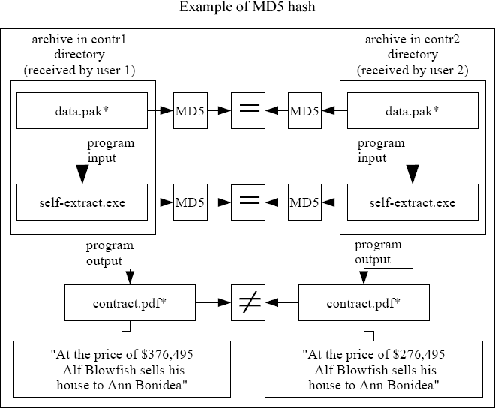

<Figure 3>
(caption: Both executables and data files have the same MD5 hash, though running those programs result in different contracts extracted.
*) Files have identical names, but different contents)
(Image obtained from <>)

Works Cited

Steven H. van Leeuwen. “Data Encryption.” Bartleby.com. Online. Internet. December, 2006. <http://www.bartleby.com/65/da/dataencr.html>

Peter Meyer. “An Introduction to the Use of Encryption.” Hermetic Systems. Online. Internet. December, 2006. <http://www.hermetic.ch/crypto/intro.htm>

“Encryption.” Webopedia. Tuesday, March 16, 2004. Online. Internet. December, 2006.
<http://www.webopedia.com/TERM/e/encryption.html>

Carl Ellison. “Cryptography Timeline.” December 11, 2004. Online. Internet. December, 2006. <http://world.std.com/~cme/html/timeline.html>

Frederick W. Chesson. “SECRET WIRES * Civil War Cryptology.” July 27, 2000. Online. Internet. December, 2006. <http://pages.cthome.net/fwc/CODE.HTM>

“ROT13 Encoder/Decoder.” edoceo, inc. Online. Internet. December, 2006. <http://www.edoceo.com/utilis/rot13.php>

Steven DeGraeve. “ROT13.” DeGraeve.com. Online. Internet. December, 2006. <http://www.degraeve.com/rot13.php>

“Cryptanalysis.” Answers.com. Online. Internet. December, 2006. <http://www.answers.com/topic/cryptanalysis>

“Da Vinci: Father of Cryptography?” Wired News. Editor, Michelle Delio. April 16, 2003. Online. Internet. December, 2006. <http://www.wired.com/news/culture/0,1284,58378,00.html>

Lee Krystek. “The Secret of Leonardo Da Vinci” Museum of Unnatural Mystery. Online. Internet. December, 2006. <http://www.unmuseum.org/leocode.htm>

“hashing” Webopedia Tuesday, October 14, 2003. Online. Internet. December, 2006. <http://www.webopedia.com/TERM/H/hashing.html>

Ondrej Mikle. “Practical Attacks on Digital Signatures Using MD5 Message Digest.” December 2, 2004. Online. Internet. December, 2006. <http://eprint.iacr.org/2004/356.pdf>

TIPS ON HOW TO CREATE/CHOOSE
YOUR OWN ENCRYPTION METHOD
There are several things to look for in a good encryption method that a programmer about to create his/her own or select from the ones available should know. These tips will help in deciding what one should look for or make sure to implement. The tips are ordered by importance:
- Patterns. Every encryption method has a repeated pattern in it which the decrypt program looks for when interpreting the text. This pattern should be well hidden in your encryption scheme as it is the first thing analyzed in cryptanalysis.
- Possibilities. It is not as hard as you might think to break an encryption scheme where there is only one possibility for every word. Having only one possibility breaks rule 1 by allowing cryptanalysis to more easily discover the pattern. Make sure the method you are going to use have several different possibilities for the same plaintext.
- Noise. Noise is the placement of characters in the encrypted text that mean nothing and are not to be decrypted. An example of this can be seen in this short sentence; “Txhxex Bxaxlxlx ixsx rxexd” which decrypted says “The Ball is red.” An ‘x’ is placed in between each letter to throw off a human reader trying to decipher the text. This ‘x’ is an example of noise. Although this is not essential if the method is pretty secure without it, it is still recommended.
- Implementation Complexity. This is more of a judgment call then something to watch out for. You want to have a method that is very complex so it is hard to crack, but at the same time, if you don’t plan on spending too much time coding it in, you might want to consider how hard it is to implement. This is especially true if you are planning on having other programmers implement your method. There is no clear line on this so just make sure it is taken into account.
- Size. Sometimes when you encrypt plaintext, the size of the ciphertext is significantly larger. Make sure you have sufficient room to store the ciphertext as in most cases there is no limit to the amount of plaintext your encryption method will be used on.
- Runtime. Last item on this list so this one isn’t too important. I think it is still something to consider, however, since if you plan on encrypting a big file, the time it takes to run the encryption algorithm needs to be minimized. Most of the time this isn’t a big deal, but optimization is almost always a factor in projects.
I want to point out that these tips have come about through my own personal experience programming an encryption method as well as doing research on encryption methods and are not to be considered, in any way, a complete list. There are many other things to be considered when you are creating or choosing your own encryption method.
How the Different Encryption Methods Mentioned Compare
NAME | PATTERNS | POSSIBILITIES | NOISE | IMPLEMENT  COMPLEXITY | SIZE | RUNTIME
Vigenere | 
ROT13
ROT(n)
My own

Legend:
Patterns: 1 padlock = easy pattern to recognize
5 padlocks = hard pattern to recognize

Possibilities: 1 padlock = small number of possible ciphertexts per plaintexts
5 padlocks = large number of possible ciphertexts per plaintexts

Noise: 1 padlock = low or no amount of noise
5 padlocks = high amount of noise

Implementation Complexity: 1 padlock = very difficult to implement
5 padlocks = relatively easy to implement

Size: 1 padlock = ciphertext is large in size
5 padlocks = ciphertext is small in size

Runtime: 1 padlock = runtime is slow
5 padlocks = runtime is fast

