Game Synopsis:

Enter a futuristic world where knowledge is power and data is worth more than cash. In pursuit of that most valuable of commodities, dive into a virtual realm where you search maze-like networks while avoiding detection and, ultimately, deletion.
Explore labyrinthine systems and deal with security systems through evasion or combat, from afar or up close and personal.
First person corridor gameplay with a shoot-and-slash combat engine for ranged and melee combat.

Team Contributions:

The entire game engine was co-operatively developed by Brian and Kevin. Brian chiefly developed the virtual pivots and placement algorithms for both entity movement and collision handling, generating the basis of the self developed physics engine. Kevin developed all of the functions to build and load the level, as well as the items and item interaction, and was primarily responsible for all sprite and brush manipulation, including player, saber, and enemy health coloring, wall textures, and the radar tracking player movement. Brian was mostly responsible for developing the player fsm and handling player interaction, including saber movement and strike actions, Kevin was mostly responsible for developing the enemy fsm and implementing the AI that was co-operatively developed by both Brian and Kevin. It is difficult to definitively determine who did what for the game system, as with both coders assisting each other and recoding for optimization and stability, most of the code is a production of the combined efforts of both.
Tyler was solely responsible for the development of the GlovePIE script for the Wiimote interaction, as well as the original score for the background music, and the audio editing of event triggered sound effects. Tyler and Kevin handled sound placement in the game engine. Tyler and Mario were assigned the tasks of independently developing two levels, one apiece, using Kevin's level building tools, Tyler was the only one to complete a full level design, and created the in-game level.
Mario selected from free websites some audio files for the sounds that a suitable foley could not be recorded and prepared powerpoint slides for the midterm presentation.
We also want to extend a special thanks to Tim Wright for taking the time to test our game. He was able to find various areas of improvement and greatly help the overall gameplay.

Software Design:

Game structure: For the most part, although mostly unplanned, we tried to get the different aspects of the game working first and then pretty it all up for optimization and integration. After the first recoding, the game structure was that of several tables – one each for the player, enemy, player’s projectile, game, and items. Each table contains constants in the form of nested tables, variables, and methods. The basic idea was to set each component up like a class. We then put each class in its own file. We kept this same structure and recoded when necessary to maintain its integrity.

We divided the game fsm into states that each had their own sub-states. The main states are the ones in bold below and each state under them are their sub-states.

INTRO
load: creates objects, geoms, and a brush for company name and strings for company motto.
company name drop: turns on gravity for the company name objects and waits a certain amount of time before fading in the company motto.
company logo fade in: fades in the company motto and waits a certain amount of time before fading out both company name and motto.
company fade out: fades out everything
unload: destroys intro pivot that everything was parented on thereby deleting all child entities. Returns false so global state is incremented and state Title can proceed into load state.

TITLE
load: creates all jpg images for title and positions them correctly.
menu: displays title screen and watches for mouse cursor position to swap images when a hotspot is hovered over. When the mouse is over a hotspot, the click boolean set on mouse click is checked and if true, an option has been selected and appropriate action is taken.
controls: shows the controls screen and watches for mouse input similar to menu state.
unload: destroys title pivot that everything was parented on and returns false so game state can proceed into sub-state start.
exit: calls dos command to kill any GlovePIE application open and exits electro.

GAME
start: loads up all entities needed to start game such as pause screens, pause cursor, and win screens as well as resets position of lights and calls function to load level.
load: waits for level to load and camera spin intro to finish.
play: allows player to play the game and calls function do_state on several groups of entities for enemy control, projectile moving, etc.
pause: displays pause screen
pause wait: monitors cursor position and click status on pause screen. Position and click is used similar to title menu for switching images and taking appropriate action.
unload mainmenu: kills level and redirects to title menu.
death overlay fall setup: sets up image creation and position for death animation.
death overlay fall: scales down death images to create effect. When scales reaches set amount, it switches to unload gameover.
unload gameover: kills level and redirects to gameover load.
win setup: starts win animation of fading out level. When alpha reaches 0, it displays win screen and switches to win wait.
win wait: monitors cursor position and click status on win screen. Position and click is used similar to title menu for switching images and taking appropriate action.
exit: calls dos command to kill any GlovePIE application open and exits electro.

GAMEOVER
load: loads images, displays main image, resets camera and lights position, creates custom cursor, and plays player death sound.
menu: monitors cursor position and click status on gameover screen. Position and click is used similar to title menu for switching images and taking appropriate action.
unload: destroys gameover pivot that everything was parented on, sets global state, and returns false so game state can backtrack to title load.
reenter setup: destroys gameover pivot that everything was parented on, sets global state, and returns false so game state can backtrack to game start.
exit: calls dos command to kill any GlovePIE application open and exits electro.
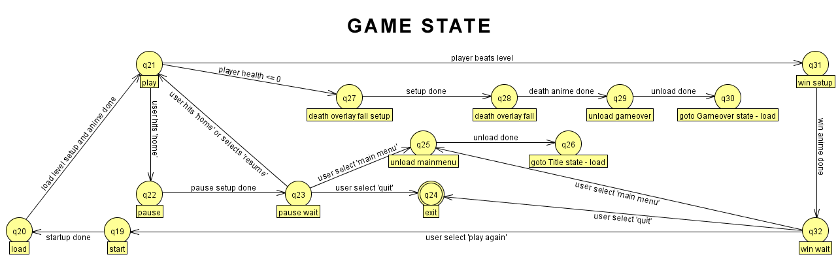
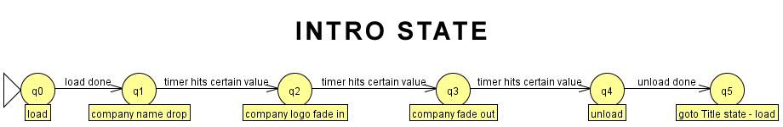

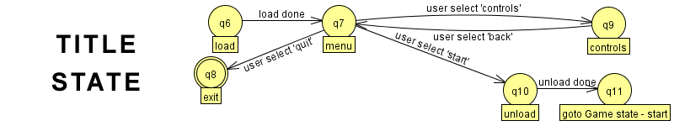

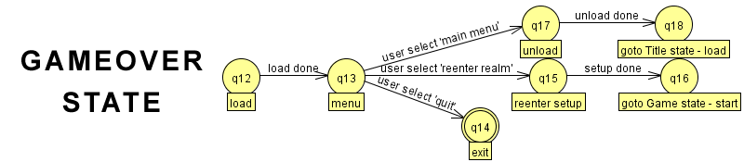
Explanation of enemy AI:
The enemy fsm is composed of the following states:

Idle – Player is out of specified range and enemy does nothing.
Alert – Player is within specified range. Enemy in this state shoots out invisible “sight shots” towards the player. If a sight shot hits the wall, enemy stays in the alert state unless player becomes out of range, in which case he moves back to the idle state. If a sight shot hits the player, enemy moves into the chase_player state.
Chase_player – Player is within range and enemy can “see” player (that is, sight shots from enemy hit player). Enemy continues to fire sight shots and as long as they hit the player, he stays in the chase_player state. When a sight shot hits the wall, he moves into the chase_memory state. During this state the enemy is combat active and periodically fires a bullet in the direction it is facing. If the player is within melee range, he switches to the melee state.
Chase_memory – Player is within range but cannot currently be seen. While in alert or chase_player, each time a sight shot hits the player, the player’s position is recorded into the enemy’s “memory.” If the player gets out of the enemy’s sight (i.e. the sight shot hits a wall), the enemy will begin chasing the last spot he “saw” the player (i.e. the last recorded position of the player via the last sight shot that hit the player). When the enemy gets within a small range of the spot he “remembers” seeing the player, he moves into the alert state. From here, he either can see the player (or at least turn to where the player is and then see him) in which case he moves back to the chase_player state, or the player has already moved out of his specified range, in which case the enemy moves to the idle state. If, however, he sees the player before reaching this memory point, he will move directly into the chase_player state. This is accomplished by continuing to fire sight shots. If a sight shot hits a wall, it is ignored. If it hits the player, enemy moves into the chase_player state.
Melee – Player is in close combat range. The enemy automatically turns to face the player and if the player is already in front of the enemy it moves forward until it is at its closest range. Melee is also a combat active state and the enemy fires periodically while he is in it.

Visual Effects:

All 2D sprites/textures: Custom made in Adobe Fireworks 8
All 3D models: Custom made in Wings 3D, MakeHuman, and Google Sketchup

Enemy design: Our original enemies were advanced geometric shapes with a wireframe “shell” (2 entities, one solid, one with wireframe turned on made up the enemy). The problem with this, as Dr. Leigh pointed out, was that they didn’t look like they fit. Not only that, but they didn’t look evil enough. So to remedy this, we remade them with sharp edges and more detail. Also, instead of the entire enemy changing color to reflect its remaining health, only the wireframe does. We thought this looked better because the wireframe still indicated the health with a highlight of color, but the body of the enemy remained a dark hue further adding to their more sinister appearance.
Enemy projectile: Is a sprite that resembles static energy. We had a couple of images we tried first but most of them didn’t look like a projectile but more like a moving image. The illusion of depth achieved by the alpha changes on the sprite makes it look like it could be a three dimensional object that is only being viewed from one direction, so it was accepted while others were rejected.
Player design: First the full body avatar at the beginning of the level. This was used only for the level intro and gives the player a view of what he is controlling. We went after the whole Tron idea with the black (instead of gray) suit and blue outlines. The avatar you are actually controlling is a set of pivots with geoms and a disembodied arm with a saber at the end. The arm shows a close up of the suit and the color outline shows the player’s health.
Player’s saber: This was definitely tricky. The original saber didn’t look much like a saber. We actually didn’t even start out with the concept of a saber (or at least we weren’t completely in agreement on one). When we did decide on one, the only hint that it was a saber was that it was unlit. With no glow it wasn’t too convincing. After adding an animated glow, we realized that, although it looked alright, it didn’t show any trail. To remedy this, the low alpha auras being generated around the original saber are not fixed to the saber’s position, they are left were the saber was on that frame. This creates lasting “echoes” that fade out from wherever the saber had been.
Player’s projectile: The idea was when you swing a saber, it leaves a light trail. We wanted to solidify this trail and have to move outward from the player. This is what you are essentially creating. To create the projectile we used Google Sketchup and Wings 3D to create an arched rectangular like object. We then used Electro to control the coloring depending on the type of slash created. The coloring of the extreme slash is randomized with each frame.
Walls: The walls are models that are scaled in Electro. We couldn’t get Electro to change the texture units of the wall after using what came straight out of the documentation, so instead we made sprites of the different wall textures and scaled and rotated them to fit the wall and be positioned on the side the player would see. Because set_sprite_range was working, we could repeat the texture of the sprites to make it look right. The idea was a virtual grid pattern to set the tone of the game.

Audio Effects:

The game audio is almost completely original. The background music was composed by Tyler and mixed using Fruity Loops, the event sounds in game are mostly foley sounds recorded over several recording sessions and edited using Audacity.

Design tradeoffs:

Original Idea: Our original idea was that of a Syndicate type game with hit-men for hire. It was suppose to be a command and conquer style game with a net-dive feature for unlocking doors and gaining access to certain areas. While we still think this would have been a great game to make, it was a good bit out of the range of possibilities given the time constraint. So we basically had to abandon all but the net-dive feature and actually turn the net-dive into our game. This turned out to be quite enough to go on.
Puzzle Idea: Also in our original idea was the concept of solving puzzles while in game play. The idea was that certain doors could be opened in one of two ways: 1. Brute force but striking the door and attempting to knock it down. This would attract a multitude of enemies that you would have to deal with. 2. Solve a puzzle stealthily without attracting attention and if successful, then the door would open. This again turned out to be too time consuming to add.
Wiimote Control: For our midterm demo, the player could only move the Wiimote short distances while pointing at the screen. We wanted, however, for the player to have to do a full swing with their arm. The really tricky part of this is that the Wiimote ONLY reports its acceleration and axis of movement but not its direction along the axis. So moving the Wiimote left will report the same values as moving it right (and the same for up/down, towards/away from the screen). So the entire GlovePIE script had to be rewritten (in fact several times) to get the correct motion to fire a projectile. As it stands our script still can't tell the difference in direction so a fast swing up will still trigger the creation of a projectile.
3D Menus: We wanted to have 3D menus but due to lack of time we have to settle for 2D sprites.
Enemy Explosion: We had planned for the enemy to explode (edges go everywhere) whenever you hit the enemy as his frame is falling after he is killed. Again lack of time was the reason we didn't do this.
Wall Textures: Instead of having the texture put on the wall and repeated, we actually make sprites that are very close to the wall that repeat. We couldn't get Electro to properly repeat textures so this was our alternative. This lead to further optimization to keep frame rate high but it worked out.
Saber Trail: The trail didn't really fit what we had in mind since when you sidestep, the duplicated sprites are too apparent and it breaks the illusion of a glowing trail. However, there were some people who said they liked it after seeing the game so we decided to leave it as is.
Overall Textures: It was kind of hard to make really nice looking textures to make the game look more realistic when our theme was that of a virtual environment. We ended up settling with the design and moving on to focus more on gameplay.
Boss Death Animation: We wanted to do something different for the boss's death animation from a regular enemy's death animation but we didn't have time.
Shadow and Reflection of Player: This was an effect that would have looked good but would have broken the virtual environment theme we were going for, so we decided against it.
Camera Range: The struggle between giving the player a long field of view vs running into lag problems showed up here. We settled on a nice compromise.
Sky Background: A sky globe constantly rotating was in our game for a good 3/4 of the class but was eventually taken out since it became apparent that there were no open areas in our level for the player to notice it.
Reflection of Enemy Fire: This concept was developed pretty early on to give the player another use of his saber. The idea was to swing the saber at the right time hitting the enemy bullet and having it reflect back at the enemy. This never took high priority and was eventually abandoned.

